Exercise 1: Association Relationship Question 2

1. UML Diagram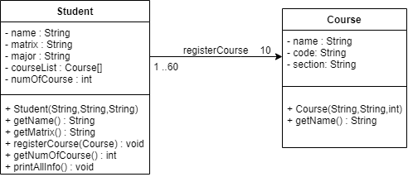
2. 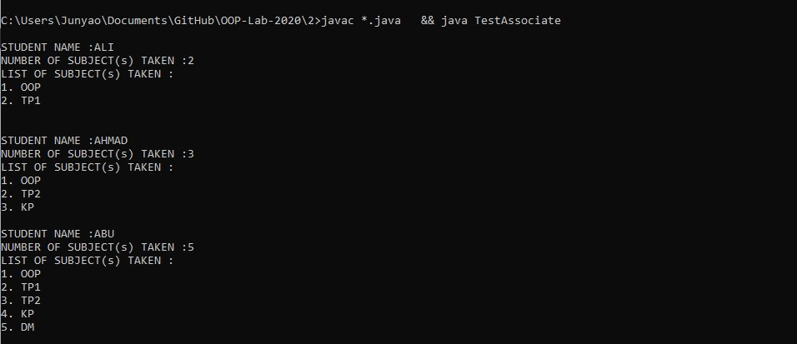
3. 

Exercise 1: Association Relationship Question 3

1. UML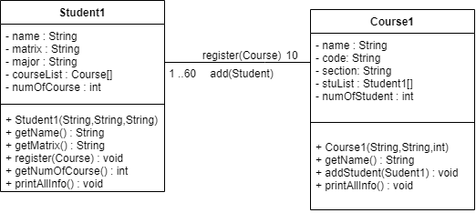
2. 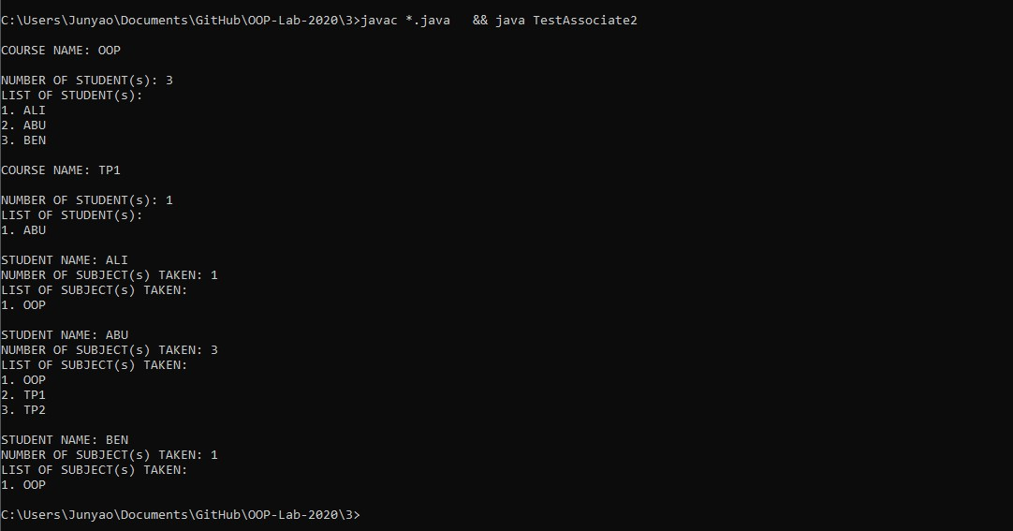
3. 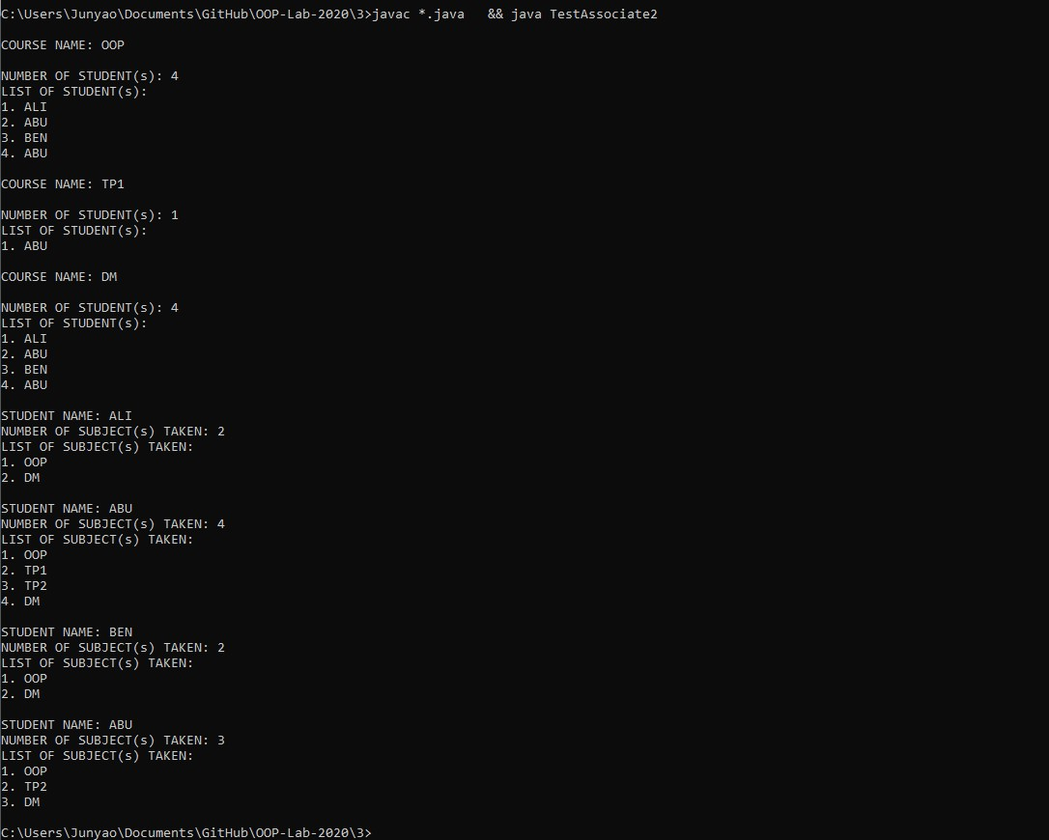

Exercise 2: Association Relationship Question 4

1. UML

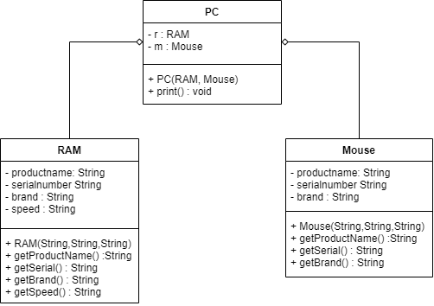

1. 
2. 

Exercise 3: Composition Relationship Question 1

|  |  |  |
| --- | --- | --- |
|  | Aggregation | Composition |
| Lifetime | Independent lifetime | Owner’s lifetime |
| Relation | Has-A | Owns |
| Upon Destruction | Destroying owning object does not affect the containing object | Destroyed when owning object is destroyed |

Exercise 3: Composition Relationship Question 4

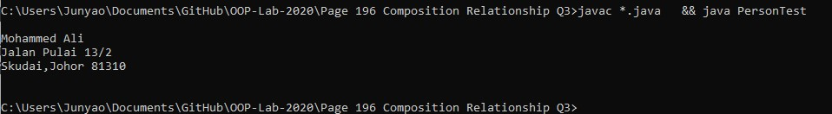

Figure 1: Output of the program

The Person class have a aggregation relationship with the Address class, and have a composition relationship with the Name class. This can be justified since Name object is constructed in the Person’s constructor, where Address object is being passed as a parameter for the Person’s constructor. Hence indicates that Name object can only exist if the owning Person exist, while the Address class can exist independently (which is logical on the other hand which multiple people may share one same address).

The output of the program is generated by calling the println function, which the Person class has overloaded from the parent Java Object class. The Person class’s toString implementation returns the output of the getFullName method from the Name object and the getFullAddress method from the Address object.

Exercise 3: Problem Solving Question 4

Section.Java  
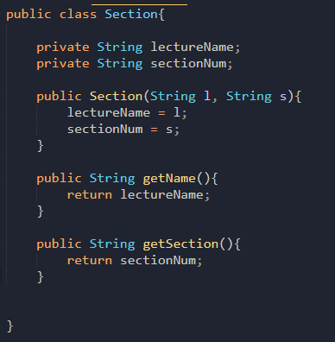

Subject.java

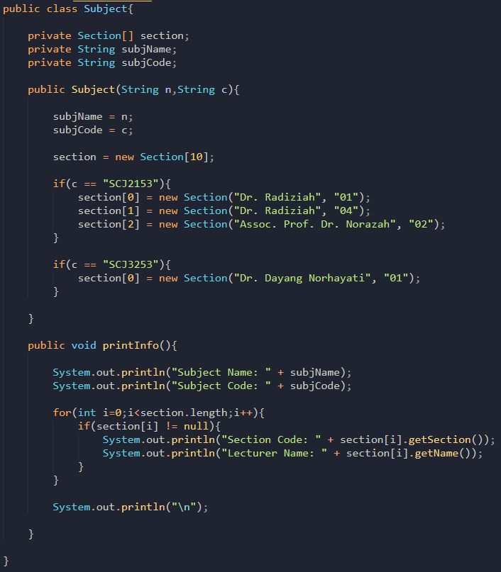

SubjectTest.java

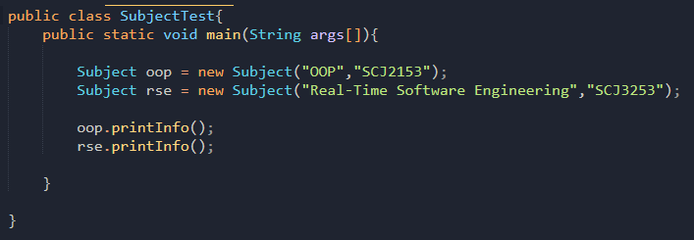

Output

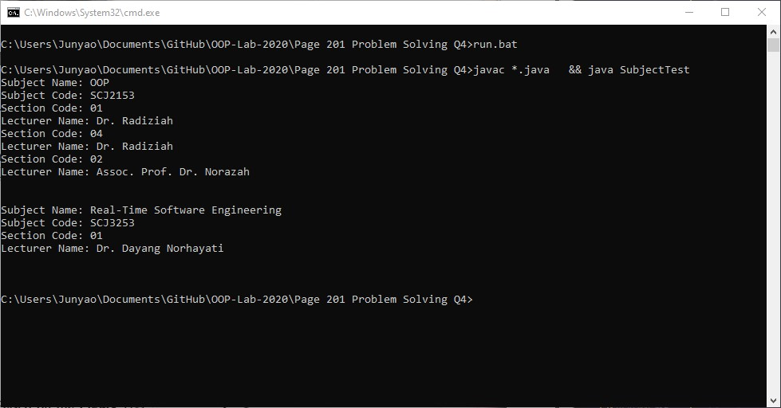

Discussion:

To create composition relationship between the Section class and Subject class, an if block is introduced in the Subject class’s constructer to identify the Subject being created, hence construct corresponding Section object.

The printInfo method of Subject object is then called to display output.